**Dundee’s Kanzen Karate teams up with Morgan Academy to launch UK-first high performance school**

The innovative programme is designed to provide pupils with a unique opportunity to excel both in sport and school.

*by* [**Laura Devlin**](https://www.thecourier.co.uk/author/lauradevlin/)

June 10 2024, 6:00am



The programme aims to develop young Karate athletes by offering top-tier training and resources. Image: Kanzen Karate.

Dundee charity Kanzen Karate has teamed up with Morgan Academy to launch a UK-first high performance sport school.

The innovative programme, which will be open to kids across the country, is designed to provide pupils with a unique opportunity to excel both in sport and school.

Named the High-Performance School of Karate, the programme aims to develop young Karate athletes by offering top-tier training and resources.

**Programme aims to inspire next generation**

Under the guidance of Kanzen’s experienced coaches, students will have access in school time to Kanzen and personalised training programs tailored to help them achieve sporting success at local, national, and international levels.

Morgan Academy’s staff will work closely with Kanzen to provide a balanced and holistic approach to student development with students being released in school time to train in their sport.

Pupils from across the country will be able to apply to be part of the performance school at Morgan Academy.

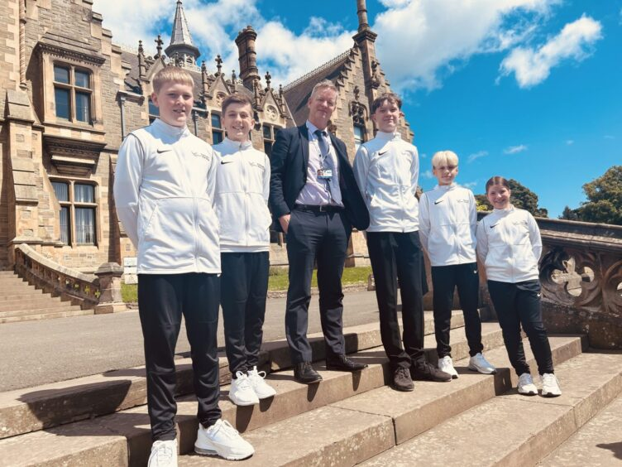

Morgan Academy headteacher Johnny Lothian with karate pupils. Image: Kanzen Karate

Johnny Lothian, headteacher of Morgan Academy, said: “We are thrilled to partner with Kanzen Karate to offer the very first High-Performance School of Karate in the country.

“Our goal is to provide our students with unparalleled opportunities to achieve their full potential, both in their academic pursuits and in their chosen sport.

“Kanzen has a track record of delivery in the sport as well as in the community. We look forward to seeing the school grow and develop in the years ahead.”

**Dundee karate hub**

Last July, Kanzen Karate hosted the World Karate Championships which saw [more than 4,000 athletes, coaches, officials and spectators from over 30 different countries come to Dundee](https://www.thecourier.co.uk/fp/news/dundee/4563622/world-karate-championships-dundee-best-ever/).

And chief officer Roy O’Kane says he hopes the Morgan Academy initiative can help inspire a new generation of athletes.

He said: “This new venture is a fantastic opportunity to develop talent and support high level athletes in the school setting.

Competitors from across the world came together in Dundee last year in search of medals and titles. Image: Kenny Smith/DC Thomson

“We will work with a range of experts including the school to ensure the athletes get the best support to help them to achieve their goals.

“I would like to praise Morgan Academy for their vision with this project and we can’t wait to get started.”

The High-Performance Karate School at [Morgan Academy](https://morgan.ea.dundeecity.sch.uk/) is set to begin its first intake of students after the summer.

It is open all Karate practitioners regardless of club or style. Please contact info@kanzenkarate.net for more information.